**Git Commands**

* **git config**

**Usage: git config –global user.name “[name]”**

**Usage: git config –global user.email “[email address]”**

This command sets the author name and email address respectively to be used with your commits.

Git Config Command - Git Commands - Edureka

* **git init**

**Usage: git init [repository name]**

This command is used to start a new repository.

GitInit Command - Git Commands - Edureka

* **git add .**

This command adds one or more to the staging area.

Git Add Command - Git Commands - Edureka

* **git commit**

**Usage: git commit -m “[ Type in the commit message] ”**

This command records or snapshots the file permanently in the version history.

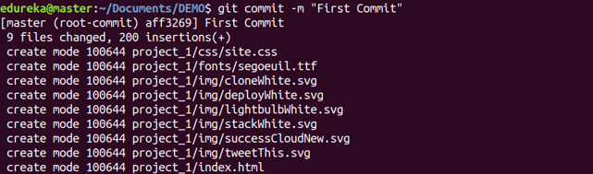

* **git remote**

**Usage: git remote add origin [Remote Server Link]**

This command is used to connect your local repository to the remote server.

Git Remote Command - Git Commands - Edureka

* **git status**

**Usage: git status**

This command lists all the files that have to be committed.

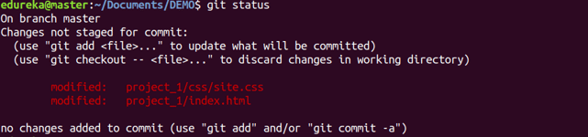

**git push**

**Usage: git push [variable name] master**

This command sends the committed changes of master branch to your remote repository.

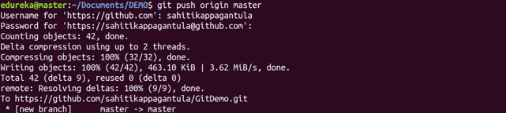

* **Check Remote Origin**

git remote -v

* **Change Remote Origin**

  git remote set-url origin git@github.com:USERNAME/REPOSITORY.git.

* **Check History**

Git reflog

Git log

**Issue Public Key**

**https://docs.github.com/en/authentication/connecting-to-github-with-ssh/generating-a-new-ssh-key-and-adding-it-to-the-ssh-agent**

ssh-keygen -t ed25519 -C [muhammadawab82002@gmail.com](mailto:muhammadawab82002@gmail.com)

cat /c/Users/muham/.ssh/id_ed25519.pub

ls -al ~/.ssh